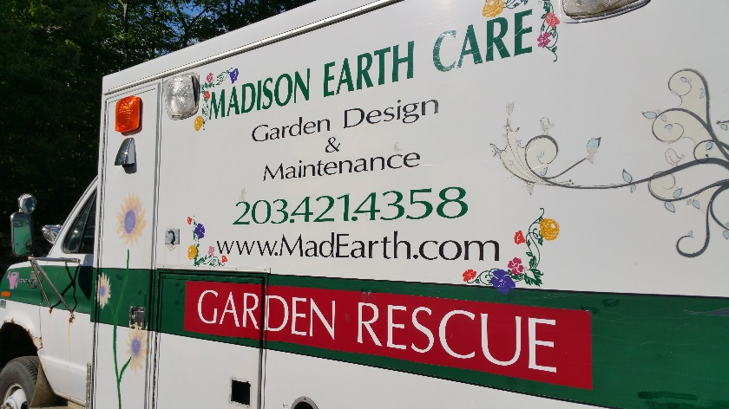
DO YOU HAVE A PASSION
FOR GARDENING?
If you do, join our team!
We install, maintain and rescue gardens!
The Garden Services Department at Madison Earth Care Landscaping is seeking a FULL-TIME seasonal HORTICULTURAL TEAM MEMBER.
The goal of the position is to create beautiful gardens to be enjoyed by their owners.
JOB REQUIREMENTS
- Must have basic knowledge of shrubs, perennials and annuals, how to install and maintain them, but also willingness to acquire more knowledge
- Must have preferably a minimum of 2+ years of gardening experience
- Must have a positive attitude, be dependable, hard-working, energetic and flexible.
- Must have excellent communication and interpersonal skills with the ability to communicate with high-end residential homeowners
- Must have a CT Drivers License and clean driving record
- Must be familiar with safe operations of landscape tools and equipment
- Must be in good health and good physical condition
- Must be willing to work in various weather conditions
To apply send resume to mecgardenservices@gmail.com or call 203.494.7905.
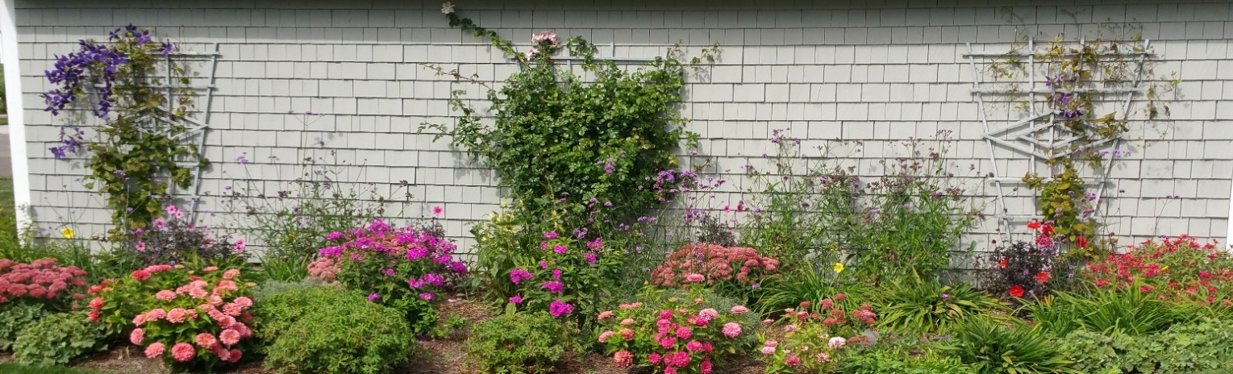
MADISON EARTH CARE LANDSCAPE & GARDEN CENTER, located in Madison, CT, provides year round maintenance services, as well as stonework, general landscaping, lawn installation and maintenance, landscape and garden design and installation, lighting, construction services and more. We are striving to provide exceptional customer service.
Website http://madisonearthcare.com/

